Belongly
A comprehensive social media policy for your therapy practice
[ Please modify the policy as you see fit for your own practice ]

The community for mental health professionals.
A free, secure space for mental health professionals to collaborate with and meet new colleagues, support each other with referrals and stay connected to a trusted network of peers.

Join Today

[Update Your Name & Practice Name] Add Your State & License #

My Private Practice Social Media Policy
This document outlines my office policies related to use of Social Media. Please read it to understand how I conduct myself on the Internet as a mental health professional and how you can expect me to respond to various interactions that may occur between us on the Internet.

If you have any questions about anything within this document, I encourage you to bring them up when we meet. As new technology develops and the Internet changes, there may be times when I need to update this policy. If I do so, I will notify you in writing of any policy changes and make sure you have a copy of the updated policy.

Friending
I do not accept friend or contact requests from current or former clients on any social networking site (Facebook, LinkedIn, etc). I believe that adding clients as friends or contacts on these sites can compromise your confidentiality and our respective privacy. It may also blur the boundaries of our therapeutic relationship. If you have questions about this, please bring them up when we meet and we can talk more about it.

Fanning / Liking
I keep a Facebook Page for my professional practice to allow people to share my blog posts and prac- tice updates with other Facebook users. All of the information shared on this page is available on my website.

You are welcome to view my Facebook Page and read or share articles posted there, but I do not ac- cept clients as Fans of this Page. I believe having clients as Facebook Fans creates a greater likelihood of compromised client confidentiality and I feel it is best to be explicit to all who may view my list of Fans to know that they will not find client names on that list. In addition, the American Psychological Association’s Ethics Code prohibits my soliciting testimonials from clients. I feel that the term “Fan” comes too close to an implied request for a public endorsement of my practice.

Note that you should be able to subscribe to the page via RSS without becoming a Fan and without creating a visible, public link to my Page. You are more than welcome to do this.

Update this with your contact information, including your name, practice name,
office address, phone number, website and email address

[Update Your Name & Practice Name] Add Your State & License #

Following

I publish a blog on my website and I post psychology news on Twitter. I have no expectation that you as a client will want to follow my blog or Twitter stream. However, if you use an easily recognizable name on Twitter and I happen to notice that you’ve followed me there, we may briefly discuss it and its potential impact on our working relationship.

My primary concern is your privacy. If you share this concern, there are more private ways to
follow me on Twitter (such as using an RSS feed or a locked Twitter list), which would eliminate your having a public link to my content. You are welcome to use your own discretion in choosing whether to follow me.

Note that I will not follow you back. I only follow other health professionals on Twitter and I do not follow current or former clients on blogs or Twitter. My reasoning is that I believe casual viewing of clients’ online content outside of the therapy hour can create confusion in regard to whether it’s being done as a part of your treatment or to satisfy my personal curiosity. In addition, viewing your online activities without your consent and without our explicit arrangement towards a specific purpose could potentially have a negative influence on our working relationship. If there are things from your online life that you wish to share with me, please bring them into our sessions where we can view and explore them together, during the therapy hour.

Interacting
Please do not use SMS (mobile phone text messaging) or messaging on Social Networking sites such as Twitter, Facebook, or LinkedIn to contact me. These sites are not secure and I may not read these messages in a timely fashion. Do not use Wall postings, @replies, or other means of engaging with me in public online if we have an already established client/therapist relationship. Engaging with me this way could compromise your confidentiality. It may also create the possibility that these exchanges become a part of your legal medical record and will need to be documented and archived in your chart.

If you need to contact me between sessions, the best way to do so is by phone by calling [ Insert your phone number here ]. Direct email at [ Insert your email address here ] is second best for quick, adminis- trative issues such as changing appointment times. See the email section below for more information regarding email interactions.

Update this with your contact information, including your name, practice name,
office address, phone number, website and email address

[Update Your Name & Practice Name] Add Your State & License #

Use of Search Engines
It is NOT a regular part of my practice to search for clients on Google or Facebook or other search engines. Extremely rare exceptions may be made during times of crisis. If I have a reason to suspect that you are in danger and you have not been in touch with me via our usual means (coming to appointments, phone, or email) there might be an instance in which using a search engine (to find you, find someone close to you, or to check on your recent status updates) becomes necessary as part of ensuring your welfare. These are unusual situations and if I ever resort to such means, I will fully document it and discuss it with you when we next meet.

Google Reader
I do not follow current or former clients on Google Reader and I do not use Google Reader to share articles. If there are things you want to share with me that you feel are relevant to your treatment whether they are news items or things you have created, I encourage you to bring these items of interest into our sessions.

Business Review Sites
You may find my psychology practice on sites such as Yelp, Healthgrades, Google My Business, Yahoo Local, Bing, or other places which list businesses. Some of these sites include forums in which users rate their providers and add reviews.Many of these sites comb search engines for business listings and automatically add listings regardless of whether the business has added itself to the site. If you should find my listing on any of these sites, please know that my listing is NOT a request for a testimonial, rating, or endorsement from you as my client.

The American Psychological Association’s Ethics Code states under Principle 5.05 that it is unethical for psychologists to solicit testimonials: “Psychologists do not solicit testimonials from current therapy clients/patients or other persons who because of their particular circumstances are vulnerable to undue influence.”

Of course, you have a right to express yourself on any site you wish. But due to confidentiality, I cannot respond to any review on any of these sites whether it is positive or negative. I urge you to take your own privacy as seriously as I take my commitment of confidentiality to you. You should also be aware that if you are using these sites to communicate indirectly with me about your feelings about our work, there is a good possibility that I may never see it.

Update this with your contact information, including your name, practice name,
office address, phone number, website and email address

[Update Your Name & Practice Name] Add Your State & License #

If we are working together, I hope that you will bring your feelings and reactions to our work directly into the therapy process. This can be an important part of therapy, even if you decide we are not a good fit. None of this is meant to keep you from sharing that you are in therapy with me wherever and with whomever you like. Confidentiality means that I cannot tell people that you are my client and my Ethics Code prohibits me from requesting testimonials. But you are more than welcome to tell anyone you wish that I’m your therapist or how you feel about the treatment I provided to you, in any forum of
your choosing.

If you do choose to write something on a business review site, I hope you will keep in mind that you may be sharing personally revealing information in a public forum. I urge you to create a pseudonym that is not linked to your regular email address or friend networks for your own privacy and protection. If you feel I have done something harmful or unethical and you do not feel comfortable discussing it with me, you can always contact the Board of Psychology, which oversees licensing, and they will review the services I have provided.

[Your State Board of Psychology]
Insert the name and the contact information for the state psychological association that over- sees your license

Location-Based Services
If you used location-based services on your mobile phone, you may wish to be aware of the privacy issues related to using these services. I do not place my practice as a check-in location on
various sites such as Foursquare, Gowalla, Loopt, etc. However, if you have GPS tracking enabled on your device, it is possible that others may surmise that you are a therapy client due to regular check-ins at my office on a weekly basis. Please be aware of this risk if you are intentionally “checking in,” from my office or if you have a passive LBS app enabled on your phone.

Update this with your contact information, including your name, practice name,
office address, phone number, website and email address

[Update Your Name & Practice Name] Add Your State & License #

Email
I prefer using email only to arrange or modify appointments. Please do not email me content related to your therapy sessions, as email is not completely secure or confidential. If you choose to
communicate with me by email, be aware that all emails are retained in the logs of your and my Internet service providers. While it is unlikely that someone will be looking at these logs, they are, in theory, available to be read by the system administrator(s) of the Internet service provider. You should also know that any emails I receive from you and any responses that I send to you become a part of your legal record.

Conclusion
Thank you for taking the time to review my Social Media Policy. If you have questions or concerns about any of these policies and procedures or regarding our potential interactions on the Internet, do bring them to my attention so that we can discuss them.

Acknowledgement of Review of Social Media Policy
By signing below, I am indicating that I have read this document, understand my rights as a client, and accept the responsibility as stated. I have been offered a printed copy of the Social Media Policy and all questions regarding these policies have been answered to my satisfaction. This document is also available at [ Insert your website address here ]

Name: Name: Name: Name: Therapist:
Date: Date: Date: Date: Date:

Update this with your contact information, including your name, practice name,
office address, phone number, website and email address

More Popular Resources For Therapists
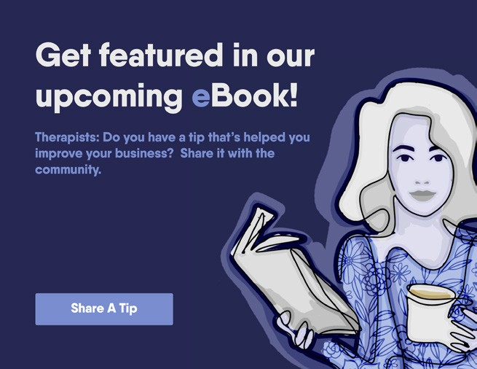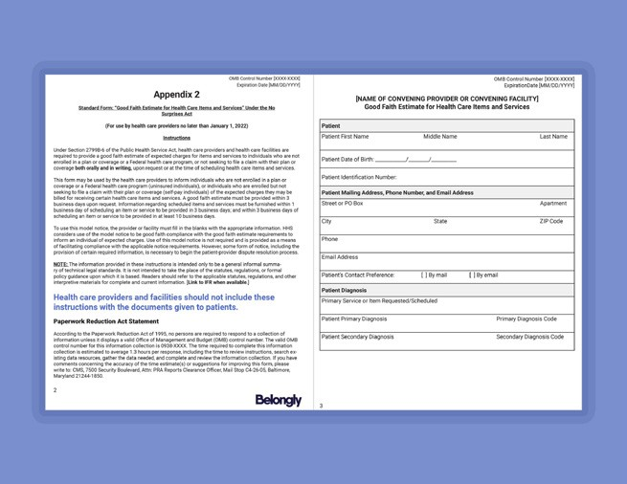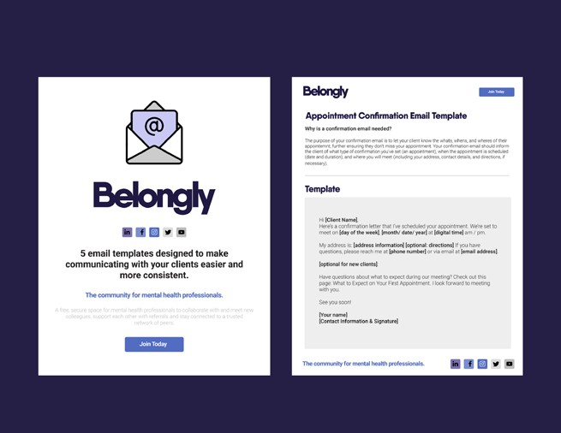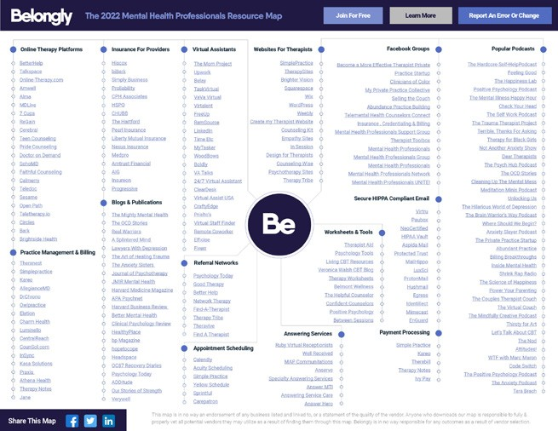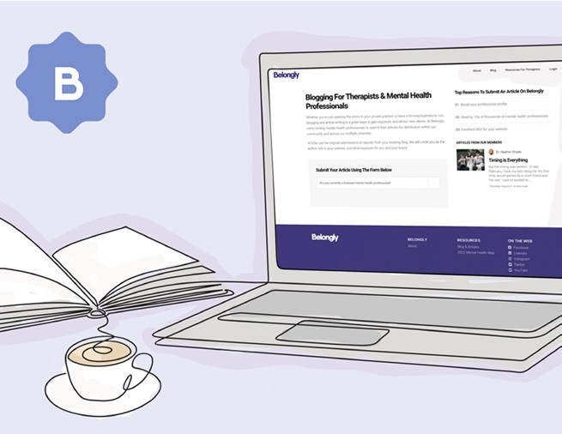

Get featured in our upcoming eBook

Good Faith Estimate Form For Therapists [ Free Downloadable Template ]

Good Faith Estimate Form For Therapists [ Free Downloadable Template ]

The 2022 Mental Health Professionals Industry Resource Map

Publishing For Therapists & Mental Health Professionals

The Glossary Of Mental Health Diagnoses

Free Videos Worth Watching

WEBINAR: Grow your online course offering and social media presence

WEBINAR: How to build a thriving mental health practice.

Belongly
The community for mental health professionals.
A free, secure space for mental health professionals to collaborate with and meet new colleagues, support each other with referrals and stay connected to a trusted network of peers.

Join Today
Learn More

Belongly is a secure private platform. Currently, we only accept US-based therapists.

Connect
Meet other psychologists, social workers, and mental health professionals who share your specialties, interests, and day-to-day challenges.
See who’s on Belongly

Collaborate
Consult on cases, securely discuss specific issues, and learn from a protected space. Help one another by giving and receiving professional support.
Get Connected

Curate
With Belongly, you can find and subscribe to the latest industry news, research, and curated articles you need to stay current and informed.

Subsscribe To Publications

Cultivate
Grow your practice with referrals from the community, and develop your business with tools, advice, best practices, and continued training.

Exchange Referrals

